

731-376-8373 www.middletonfbc.org

Rev. Matthew Jones - Pastor
Donnie Sipes, Music Director
Dianne O’Daniel, Pianist
__________________________________________________________________________________________________
MORNING WORSHIP
November 16, 2025
Prelude
Announcements
Welcome & Fellowship

*Hymn 133 “Shout to the Lord” Congregation
*Hymn 640 “Let All Things Now Living” Congregation
Prayer
Hymn 533 “Set My Soul Afire” Congregation
Scripture – Isaiah 12

*Hymn 304 “Crown Him with Many Crowns” Congregation
*Hymn 668 “Doxology” Congregation
Offering

Special Music
Message “Laodicea” Rev. Matt Jones
Revelation 3:14-22

*Hymn of Invitation 416 “Let Jesus Come into Your Heart” Congregation

Benediction
Postlude
*Congregation Standing if Able


November Ushers
Mac O’Daniel
and Houston Kirk

Nursery Schedule
November 16th Lori Lanier
November 23rd Callee Beth & Baylee Lanier

Join us after church on Sunday, November 30th from 1:00–3:00pm as we celebrate Karlee and Hayden with love and joy! They are registered at Shelton’s, Target, and Amazon.


Join us each Wednesday at 1pm as we work through the New Testament! Come enjoy a wonderful time in God’s Word. See Mrs. Beverly for more details.


Everyone is invited to help decorate the sanctuary on Wednesday, November 26th at 10am. Bring your creative ideas and help make our church shine with the love of Jesus this Christmas season!

Operation Christmas Child Shoeboxes
It’s that special time again to share God’s love in a simple but powerful way! Samaritan’s Purse Christmas Shoeboxes are ready for you to pick up and fill—available in the foyer and on the front pews. Filled boxes will be collected November 17–24. Postage per box is $10. You can also build a box online for $30 at samaritanspurse.org/operation-christmas-child.
Place any filled shoeboxes on the front pews. Also, let us know if you filled built a box online. Thank you for shining God’s light to a child during this season of giving.




Let us know how to pray for you! Please fill out the
Information tear off sheet and place in the offering or
us at: info@middletonfbc.org or
matt.jones@middletonfbc.org

Welcome to First Baptist Church

Today’s Date: ___________________

Name: ___________________________________

Address:

Email Address:

Home Phone: ( ) _____________________
Work Phone: ( ) ______________________
Cell Number: ( ) ______________________

Names of Children at Home:

As a Visitor is this your
- 1st Time
- 2nd Time
- 3rd Time
I am ….
- Attender
- Member

I came as a Guest of:

How did you learn of our church?
- Neighbor / Friend
- Co-Worker
- Driving By
- Special Event
- Visit from the church
- Website
- Other
My Decision Today
- I’m committing my life to Christ
- I want to be baptized
- I’m renewing my commitment
to Christ
- I want to help in the Nursery
- I want to help with Children’s
Programs

Comments, Needs, or
Prayer Requests

- For Prayer Service
- Confidential
- Website

I AM INTERESTED IN:

- Knowing how to commit my life
to Christ
- Growing in my relationship
with Christ
- Information on this church family
- A Sunday School Class
- Having a visit from the church/pastor
- Counseling
  - Pre-Marital
  - Financial
  - Crisis / Marriage
  - Other

~ PRAYER REQUESTS ~

CHURCH IN ACTION

SUNDAY 9:00 a.m. Sunday School
10:00 a.m. Morning Worship

WEDNESDAY 6:30 p.m. Prayer Meeting
Bible Study / Sanctuary Choir

Bible Recap – Ladies’ Bible Study – Wednesdays – 1:00 p.m. - Library

Please check the Blessing Box for needed items
Due to the government shutdown, many are unable to receive food assistance and are in great need. Please check the Blessing Box and help if you’re able.

________________________________________________________________________________________

Reach Up, by experiencing the heart of God in passionate worship, to
Reach In, by helping each member reach their full potential in Christ,
Reach Out, by extending Christ’s love to Middleton, TN
and to the ends of the earth.

SCHEDULE OF OUR SERVICES

Sunday 9:00 a.m. Sunday School
10:00 a.m. Morning Worship

Wednesday 6:30 p.m. Prayer Meeting
Bible Study and Sanctuary Choir

Business Meeting Wednesday evening following
the first Sunday of each month

Do you know someone who needs a ride to church? Contact us, either through text message or through GroupMe, and give us details a day before we need to pick them up. Call or Text Rodney at: 731-217-7161



First Baptist Church

525 N. Main Street, Middleton, TN 38052
www.middletonfbc.org

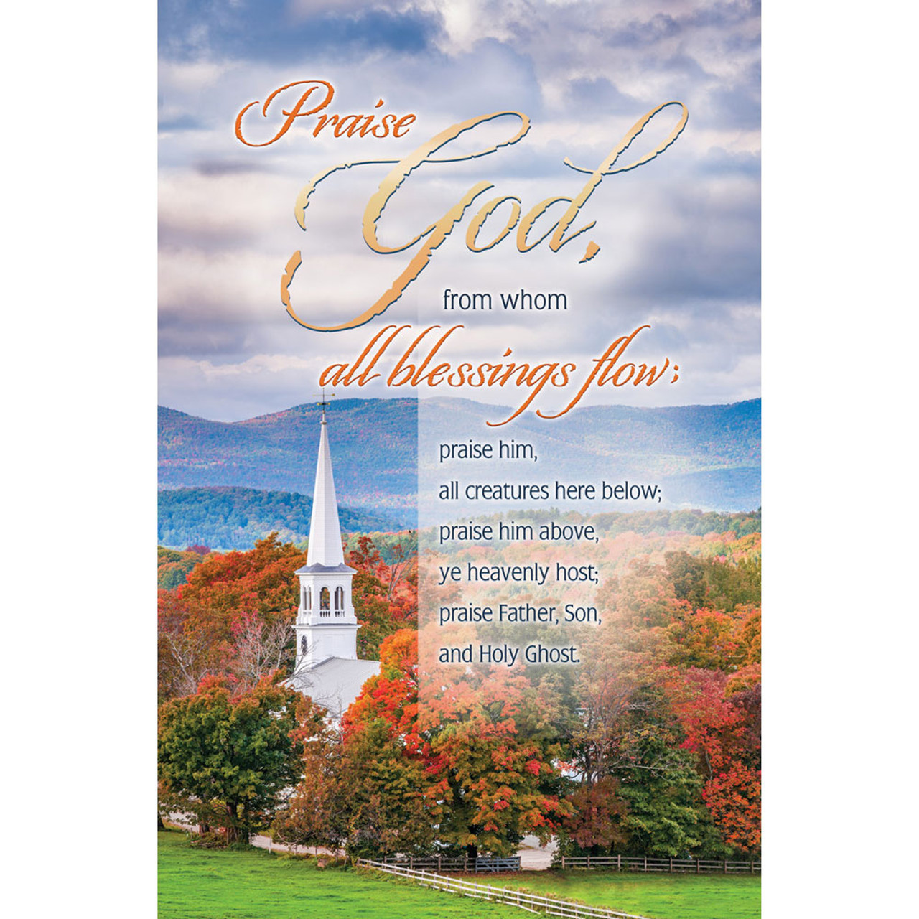

Reaching People – Touching Lives

