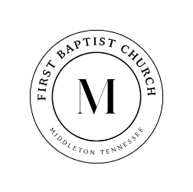

731-376-8373 www.middletonfbc.org

Rev. Matthew Jones - Pastor
Donnie Sipes, Music Director
Dianne O’Daniel, Pianist
__________________________________________________________________________________________________
MORNING WORSHIP
July 6, 2025
Prelude
Announcements
Welcome & Fellowship

*Hymn 151 “Bless His Holy Name” Congregation
*Hymn 96 “Great Is Thy Faithfulness” Congregation
Prayer
Hymn 357 “Rescue the Perishing” Congregation
Scripture – Responsive Reading - Compassion

*Hymn 626 “I Love to Tell the Story” Congregation
*Hymn 668 “Doxology” Congregation
Offering

Special Music
Message “Compassion” Rev. Matt Jones

*Hymn of Invitation 412 “The Savior Is Waiting” Congregation

Benediction
Postlude
*Congregation Standing if Able


July Ushers
Houston Kirk
and Mac O’Daniel

Nursery Schedule
July 6th Callee Beth & Bailee Lanier
July 13th LaTasha Jones


Praise Report!
We had an incredible week at Vacation Bible School with 25 children and 18 amazing workers! We learned that God created each of us for a purpose—and He has great things in store for our lives! Thank you to everyone who prayed, served, and made VBS a success!


Mark your calendars for Friday, July 25th from 4–7pm! We’ll be blessing children in our county with school supplies to help them start the year strong. Helpers are needed to prep and pack supply bags—more details coming soon!

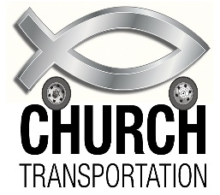
Reaching others for Christ starts with showing up—and sometimes that means giving someone a ride! Our van ministry is a vital way to connect with our community and bring people to church. We’re setting up a rotation of 2 helpers each week to pick up those in need of a ride. Please see Tasha or Matt to sign up. Thank you for being the hands and feet of Jesus!

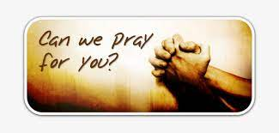
Let us know how to pray for you! Please fill out the
Information tear off sheet and place in the offering or
us at: info@middletonfbc.org or
matt.jones@middletonfbc.org

Welcome to First Baptist Church

Today’s Date: ___________________

Name: ___________________________________

Address:

Email Address:

Home Phone: ( ) _____________________
Work Phone: ( ) ______________________
Cell Number: ( ) ______________________

Names of Children at Home:

As a Visitor is this your
- 1st Time
- 2nd Time
- 3rd Time
I am ….
- Attender
- Member

I came as a Guest of:

How did you learn of our church?
- Neighbor / Friend
- Co-Worker
- Driving By
- Special Event
- Visit from the church
- Website
- Other
My Decision Today
- I’m committing my life to Christ
- I want to be baptized
- I’m renewing my commitment
to Christ
- I want to help in the Nursery
- I want to help with Children’s
Programs

Comments, Needs, or
Prayer Requests

- For Prayer Service
- Confidential
- Website

I AM INTERESTED IN:

- Knowing how to commit my life
to Christ
- Growing in my relationship
with Christ
- Information on this church family
- A Sunday School Class
- Having a visit from the church/pastor
- Counseling
  - Pre-Marital
  - Financial
  - Crisis / Marriage
  - Other

~ PRAYER REQUESTS ~

CHURCH IN ACTION

SUNDAY 9:00 a.m. Sunday School
10:00 a.m. Morning Worship

WEDNESDAY 6:30 p.m. Prayer Meeting
Bible Study / Sanctuary Choir

Bible Recap – Ladies’ Bible Study – Wednesdays – 1:00 p.m. - Library

Please check the Blessing Box for needed items

Back to School Bash:
Pray for our Back to School Bash on Friday, July 25th
________________________________________________________________________________________

Reach Up, by experiencing the heart of God in passionate worship, to
Reach In, by helping each member reach their full potential in Christ,
Reach Out, by extending Christ’s love to Middleton, TN
and to the ends of the earth.

SCHEDULE OF OUR SERVICES

Sunday 9:00 a.m. Sunday School
10:00 a.m. Morning Worship

Wednesday 6:30 p.m. Prayer Meeting
Bible Study and Sanctuary Choir

Business Meeting Wednesday evening following
the first Sunday of each month

Do you know someone who needs a ride to church? Contact us, either through text message or through GroupMe, and give us details a day before we need to pick them up.

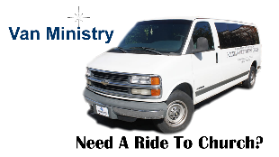

First Baptist Church

525 N. Main Street, Middleton, TN 38052
www.middletonfbc.org

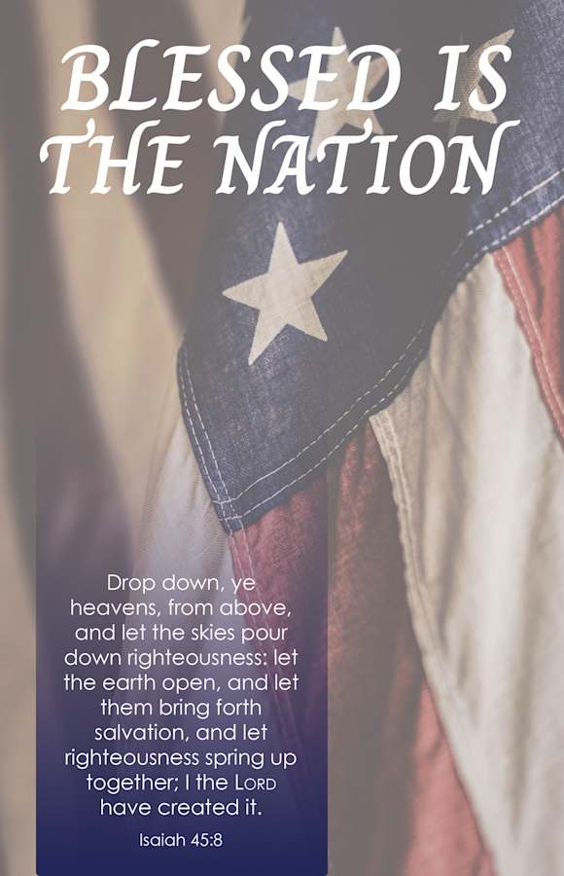

Reaching People – Touching Lives

