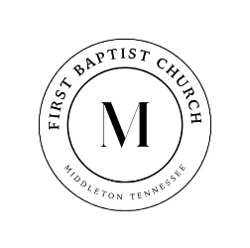

731-376-8373 www.middletonfbc.org

Rev. Matthew Jones - Pastor
Donnie Sipes, Music Director
Dianne O’Daniel, Pianist
__________________________________________________________________________________________________
The Sanctuary Choir Presents
His Name Is Jesus
Created by Dennis and Nan Allen
__________________________________________________________________________________________________

December 7, 2025

Welcome and Announcements

Fellowship Hymn 295 “All Hail King Jesus” Congregation

Hymn 176 “Come, Thou Long-Expected Jesus” Congregation

Advent - Peace

“Joy to the World! The Lord is Come” /
“O Come, All Ye Faithful”

Narration John 1:1-5 LaTasha Jones

Isaiah 9:2,6 Isabella Milford

“O Come, O Come, Emmanuel”
“And His Name”

Narration Psalm 98:1-4 Jamie Sipes

“Emmanuel”

Go Tell It on the Mountain

Narration Matthew 1:18-21 Joshua Jones

“O Holy Night”

Message Rev. Matthew Jones

Invitation “Jesus Is the Sweetest Name I Know” Choir

Finale “What Did You Say Was the Baby’s Name?”

“Hark! The Herald Angels Sing”

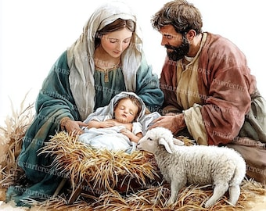

Benediction and Blessing

Welcome to First Baptist Church

Today’s Date: ___________________

Name: ___________________________________

Address:

Email Address:

Home Phone: ( ) _____________________
Work Phone: ( ) ______________________
Cell Number: ( ) ______________________

Names of Children at Home:

As a Visitor is this your
- 1st Time
- 2nd Time
- 3rd Time
I am ….
- Attender
- Member

I came as a Guest of:

How did you learn of our church?
- Neighbor / Friend
- Co-Worker
- Driving By
- Special Event
- Visit from the church
- Website
- Other
My Decision Today
- I’m committing my life to Christ
- I want to be baptized
- I’m renewing my commitment
to Christ
- I want to help in the Nursery
- I want to help with Children’s
Programs

Comments, Needs, or
Prayer Requests

- For Prayer Service
- Confidential
- Website

I AM INTERESTED IN:

- Knowing how to commit my life
to Christ
- Growing in my relationship
with Christ
- Information on this church family
- A Sunday School Class
- Having a visit from the church/pastor
- Counseling
  - Pre-Marital
  - Financial
  - Crisis / Marriage
  - Other

~ PRAYER REQUESTS ~

CHURCH IN ACTION

SUNDAY 9:00 a.m. Sunday School
10:00 a.m. Morning Worship

WEDNESDAY 6:30 p.m. Prayer Meeting
Bible Study / Sanctuary Choir

Bible Recap – Ladies’ Bible Study – Wednesdays – 1:00 p.m. - Library

Please check the Blessing Box for needed items

________________________________________________________________________________________


As we enter this season of giving, we invite you to prayerfully support the Lottie Moon Christmas Offering. Our church goal is $3,500, and every gift helps share the love of Christ around the world. Please use the special envelope provided—thank you for giving generously.

SCHEDULE OF OUR SERVICES

Sunday 9:00 a.m. Sunday School
10:00 a.m. Morning Worship

Wednesday 6:30 p.m. Prayer Meeting
Bible Study and Sanctuary Choir

Business Meeting Wednesday evening following
the first Sunday of each month

Do you know someone who needs a ride to church? Contact us, either through text message or through GroupMe, and give us details a day before we need to pick them up.



First Baptist Church

525 N. Main Street, Middleton, TN 38052
www.middletonfbc.org



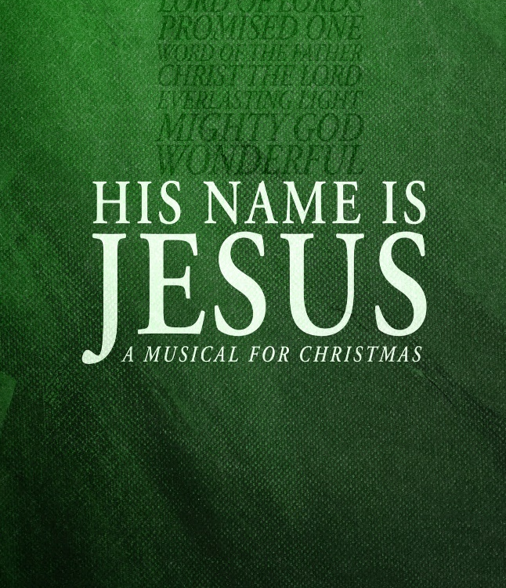

Reaching People – Touching Lives

