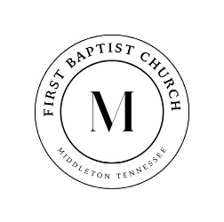

731-376-8373 www.middletonfbc.org

Rev. Matthew Jones - Pastor
Donnie Sipes, Music Director
Dianne O’Daniel, Pianist
__________________________________________________________________________________________________
MORNING WORSHIP
December 14, 2025
Prelude
Announcements
Welcome & Fellowship

*Hymn 211 “I Have Seen the Light” Congregation
*Hymn 184 “Angels We Have Heard on High” Congregation
Prayer
Hymn 197 “Sing We Now of Christmas” Congregation
3rd Sunday of Advent - Joy

*Hymn 181 “Joy to the World” Congregation
*Hymn 668 “Doxology” Congregation
Offering

Special Music
Message “You’ve Got to Have Faith” Rev. Matt Jones
Hebrews 11:1

*Hymn of Invitation 413 “Turn Your Eyes Upon Jesus” Congregation

Benediction
Postlude
*Congregation Standing if Able


December Ushers
Paul Dowty
and Charlie White

Nursery Schedule
December 14th Lori Lanier
December 21st Callee Beth & Baylee Lanier

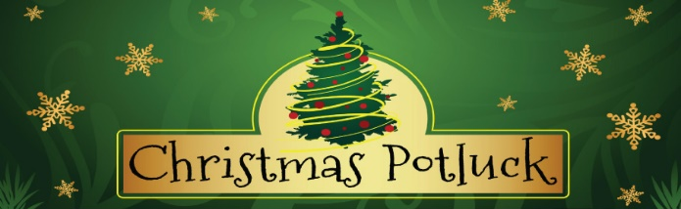

Come join us after church today as we gather for a festive Christmas Potluck! Let’s share holiday cheer, delicious dishes, and a wonderful time of fellowship as we celebrate this joyful season together. We truly look forward to spending this special afternoon with you.


As we enter this season of giving, we invite you to prayerfully support the Lottie Moon Christmas Offering. Our church goal is $3,500, and every gift helps share the love of Christ around the world. Please use the special envelope provided—thank you for giving generously.
Total received: $530


Come be a blessing to our community as we distribute food to those in need! Our next opportunity to serve this month will be this Thursday, December 18th. Please arrive at 8:00 AM as we join together to shine the light of Christ in our community.


Let us know how to pray for you! Please fill out the
Information tear off sheet and place in the offering or
us at: info@middletonfbc.org or
matt.jones@middletonfbc.org

Welcome to First Baptist Church

Today’s Date: ___________________

Name: ___________________________________

Address:

Email Address:

Home Phone: ( ) _____________________
Work Phone: ( ) ______________________
Cell Number: ( ) ______________________

Names of Children at Home:

As a Visitor is this your
- 1st Time
- 2nd Time
- 3rd Time
I am ….
- Attender
- Member

I came as a Guest of:

How did you learn of our church?
- Neighbor / Friend
- Co-Worker
- Driving By
- Special Event
- Visit from the church
- Website
- Other
My Decision Today
- I’m committing my life to Christ
- I want to be baptized
- I’m renewing my commitment
to Christ
- I want to help in the Nursery
- I want to help with Children’s
Programs

Comments, Needs, or
Prayer Requests

- For Prayer Service
- Confidential
- Website

I AM INTERESTED IN:

- Knowing how to commit my life
to Christ
- Growing in my relationship
with Christ
- Information on this church family
- A Sunday School Class
- Having a visit from the church/pastor
- Counseling
  - Pre-Marital
  - Financial
  - Crisis / Marriage
  - Other

~ PRAYER REQUESTS ~

CHURCH IN ACTION

SUNDAY 9:00 a.m. Sunday School
10:00 a.m. Morning Worship

WEDNESDAY 6:30 p.m. Prayer Meeting
Bible Study / Sanctuary Choir

Bible Recap – Ladies’ Bible Study – Wednesdays – 1:00 p.m. - Library

Please check the Blessing Box for needed items

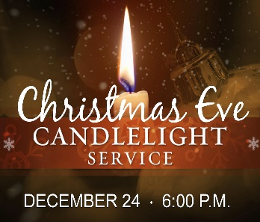
Join us for a special Christmas Eve service at 6pm as we gather to remember and honor our Lord during this sacred season.

SCHEDULE OF OUR SERVICES

Sunday 9:00 a.m. Sunday School
10:00 a.m. Morning Worship

Wednesday 6:30 p.m. Prayer Meeting
Bible Study and Sanctuary Choir

Business Meeting Wednesday evening following
the first Sunday of each month

Do you know someone who needs a ride to church? Contact us, either through text message or through GroupMe, and give us details a day before we need to pick them up.



First Baptist Church

525 N. Main Street, Middleton, TN 38052
www.middletonfbc.org

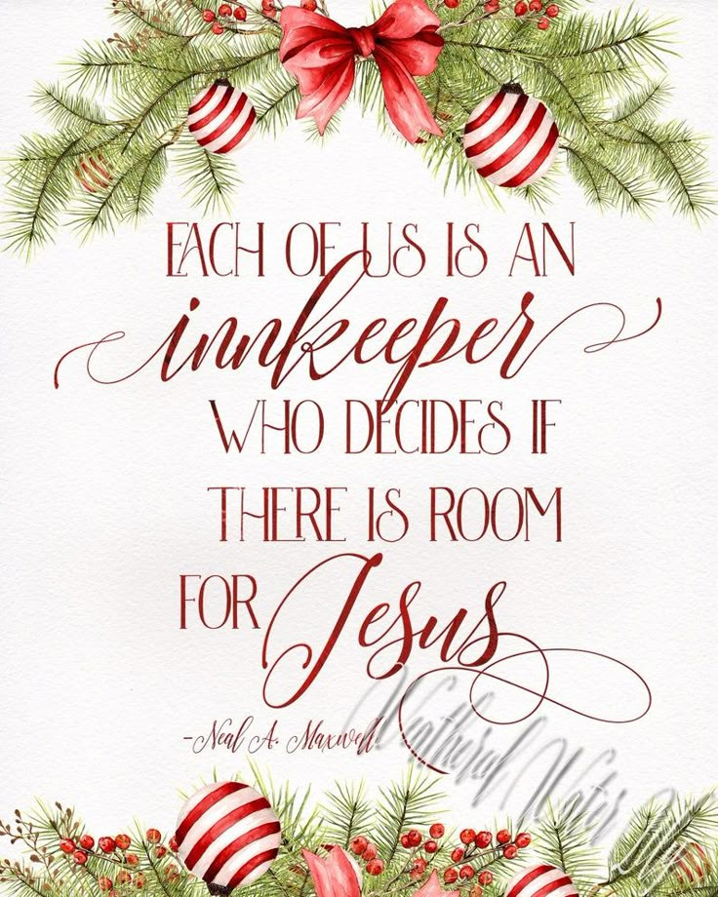

Reaching People – Touching Lives

