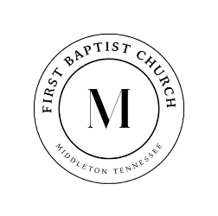

731-376-8373 www.middletonfbc.org

Rev. Matthew Jones - Pastor
Donnie Sipes, Music Director
Dianne O’Daniel, Pianist
__________________________________________________________________________________________________
MORNING WORSHIP
August 10, 2025
Prelude
Announcements
Welcome & Fellowship

*Hymn 571 “This is the Day” Congregation
*Hymn 13 “Joyful, Joyful, We Adore Thee” Congregation
Prayer
Hymn 573 “Heaven Came Down” Congregation
Scripture – Psalm 149

*Hymn 624 “Since Jesus Came into My Heart” Congregation
*Hymn 668 “Doxology” Congregation
Offering

Special Music
Message Joy Rev. Matt Jones
Isaiah 61:1-2, 7

*Hymn of Invitation 417 “Jesus is Tenderly Calling” Congregation

Benediction
Postlude
*Congregation Standing if Able


July Ushers
Paul Dowty
and Charlie White

Nursery Schedule
August 10th Tasha Jones
August 17th Beth Smith

Join us for Men’s Bible Study tonight at 5 PM —
a time of encouragement, truth, and connection as we grow in God’s Word together.



Ladies Bible Study - Join us every Wednesday at 1:00 PM in the Church Library as we dive into God's Word together. Come grow in faith and friendship—we'd love to see you there!

Seniors In Action – We are planning a special event in September!
Talk to Brother Matt if you have a special event you would like to
help plan!

Upcoming Events:
- Starting in September we will begin collecting candy for
our AutumnFest on Oct. 31st

- Friendship Tea – Saturday, Nov. 15th – Start thinking
about how you want to decorate a table and who you want
to bring!


Let us know how to pray for you! Please fill out the
Information tear off sheet and place in the offering or
us at: info@middletonfbc.org or
matt.jones@middletonfbc.org

Welcome to First Baptist Church

Today’s Date: ___________________

Name: ___________________________________

Address:

Email Address:

Home Phone: ( ) _____________________
Work Phone: ( ) ______________________
Cell Number: ( ) ______________________

Names of Children at Home:

As a Visitor is this your
- 1st Time
- 2nd Time
- 3rd Time
I am ….
- Attender
- Member

I came as a Guest of:

How did you learn of our church?
- Neighbor / Friend
- Co-Worker
- Driving By
- Special Event
- Visit from the church
- Website
- Other
My Decision Today
- I’m committing my life to Christ
- I want to be baptized
- I’m renewing my commitment
to Christ
- I want to help in the Nursery
- I want to help with Children’s
Programs

Comments, Needs, or
Prayer Requests

- For Prayer Service
- Confidential
- Website

I AM INTERESTED IN:

- Knowing how to commit my life
to Christ
- Growing in my relationship
with Christ
- Information on this church family
- A Sunday School Class
- Having a visit from the church/pastor
- Counseling
  - Pre-Marital
  - Financial
  - Crisis / Marriage
  - Other

~ PRAYER REQUESTS ~

CHURCH IN ACTION

SUNDAY 9:00 a.m. Sunday School
10:00 a.m. Morning Worship
5:00 p.m. Men’s Bible Study

WEDNESDAY 6:30 p.m. Prayer Meeting
Bible Study / Sanctuary Choir

Bible Recap – Ladies’ Bible Study – Wednesdays – 1:00 p.m. - Library

Please check the Blessing Box for needed items

________________________________________________________________________________________

Reach Up, by experiencing the heart of God in passionate worship, to
Reach In, by helping each member reach their full potential in Christ,
Reach Out, by extending Christ’s love to Middleton, TN
and to the ends of the earth.

SCHEDULE OF OUR SERVICES

Sunday 9:00 a.m. Sunday School
10:00 a.m. Morning Worship

Wednesday 6:30 p.m. Prayer Meeting
Bible Study and Sanctuary Choir

Business Meeting Wednesday evening following
the first Sunday of each month

Do you know someone who needs a ride to church? Contact us, either through text message or through GroupMe, and give us details a day before we need to pick them up.



First Baptist Church

525 N. Main Street, Middleton, TN 38052
www.middletonfbc.org
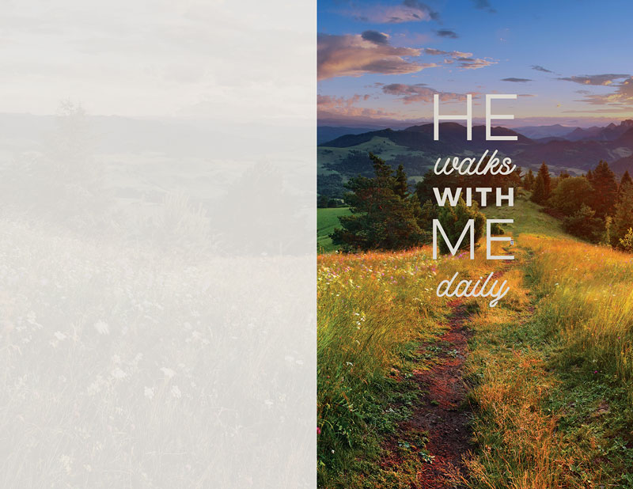

Reaching People – Touching Lives

